Name _______________________________ AP Calculus
CLASSWORK: Section 4.6: Related Rates

Show all our work!!

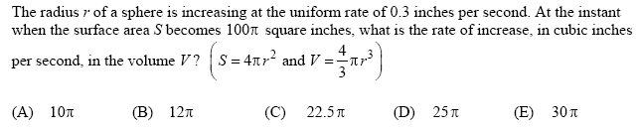
1.

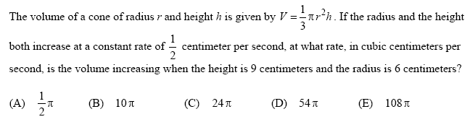
2.

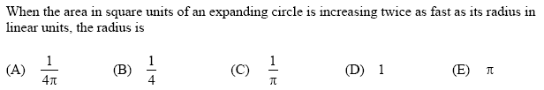
3.

4.
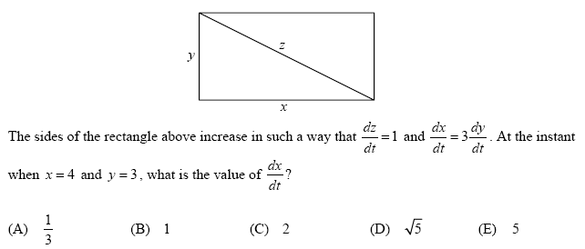

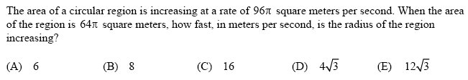
5.

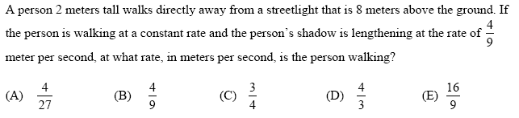
6.

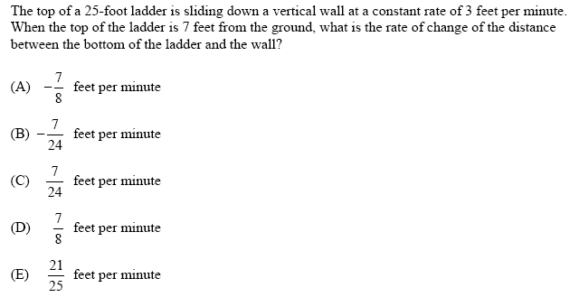
7.

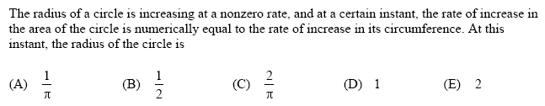
8.

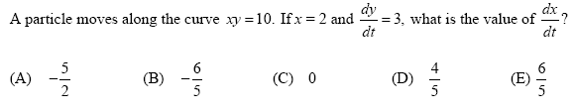
9.

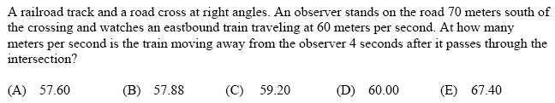
10.

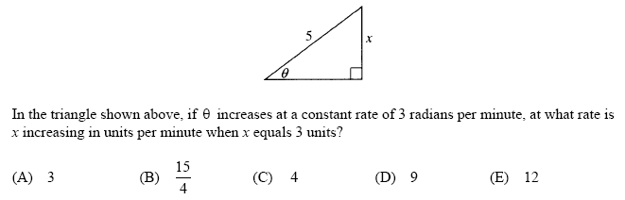
11.

